SCRIPT-CONTROLLED ACL
Restrict Record Access Based on Field Value (ServiceNow)
Vishnu MuthuPriya R
Phase 8 — Project Demonstration

Project Demonstration

Demonstration Plan
The completed solution was demonstrated live on the ServiceNow instance by walking through each role combination in increasing order of privilege, so that the effect of each individual ACL could be observed in isolation before showing the combined, fully-privileged and administrator views.

Demonstration Script
    - Show the Institution Details table structure and the sample records across ECE, EEE and CSE branches.
    - Show the four ACL records (Read, Create, Write, Delete) and their configured roles, data condition and script.
    - Impersonate the EEE user with no roles assigned — demonstrate the empty “No records to display” list.
    - Assign role bb1 and reload the list — demonstrate that only EEE-branch records now appear.
    - Assign role bb2 — demonstrate the New button appearing and a record being created.
    - Assign role bb3 — demonstrate inline editing of the Description field on an EEE record.
    - Assign role bb4 — demonstrate selecting a record and deleting it via the Actions menu, with the confirmation dialog.
    - Impersonate the System Administrator — demonstrate full visibility and control across ECE, EEE and CSE records simultaneously.

Key Screens Shown
- User and Role creation screens (User Administration → Users / Roles).
- Table and field configuration screen (System Definition → Tables).
- Access Control (ACL) configuration screen, including the Data Condition and Advanced Script sections.
- Elevate Role dialog used to gain security_admin before editing ACLs.
- Institution Details list view, shown side-by-side for the bb1-only user, the fully-privileged user, and the administrator.

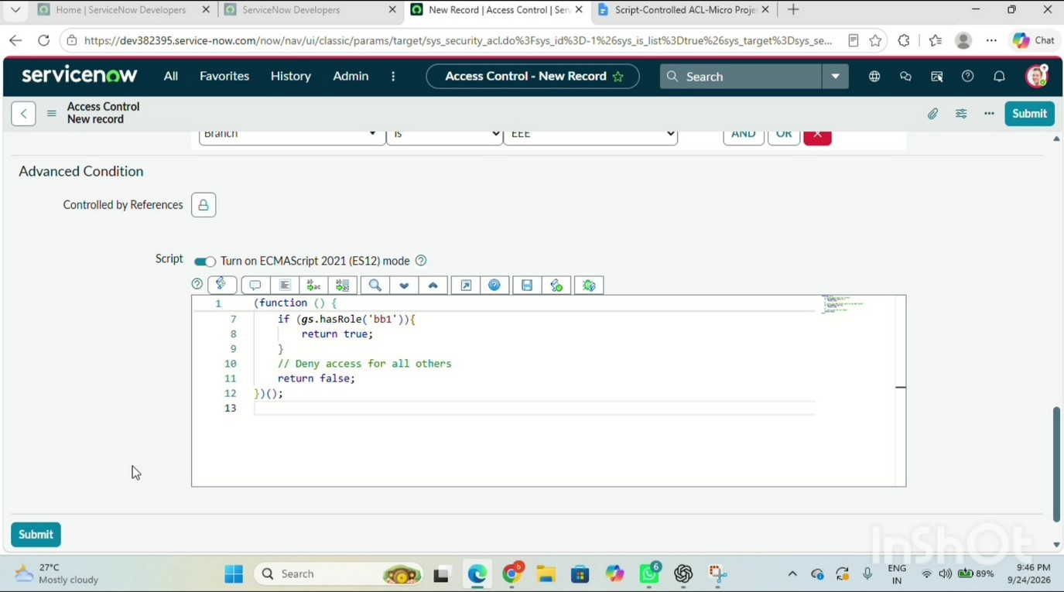
Figure 8.1: Read ACL — Data Condition (Branch is EEE) and the advanced script, shown together on the live instance
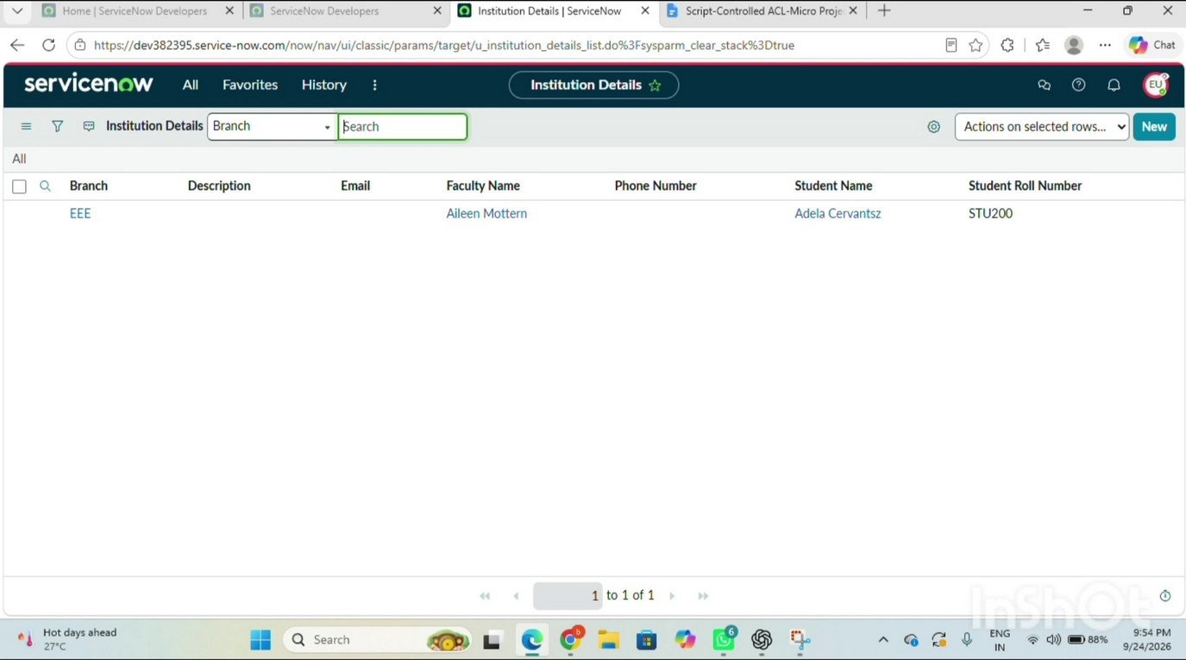
Figure 8.2: Live demonstration — impersonated EEE user sees only the EEE-branch record

Audience Takeaways
The demonstration was designed to make one point unmistakably clear: record-level security in ServiceNow is not achieved by hiding a menu item or a button in the UI, but by evaluating role membership and record data together on the server, every single time a record is requested. The side-by-side comparison of the bb1-only view, the no-role view and the administrator view made the effect of the script-controlled ACL immediately visible to the audience.

Demonstration Checklist

Item | Ready
Sample records present across ECE, EEE and CSE | Yes
Roles bb1–bb4 created and available to assign | Yes
All four ACLs active and attached to u_institution_details | Yes

Item | Ready
EEE test user account available for impersonation | Yes
Administrator account available for impersonation | Yes
  - Feedback and Closing
The demonstration concluded with a short question-and-answer discussion on how the same pattern could be extended to other tables (for example, restricting incident records by assignment group, or restricting HR records by department), reinforcing that the technique built in this micro-project is a general, reusable security pattern rather than a one-off solution specific to the Institution Details table.

Conclusion and Outcome
This project successfully implemented a script-controlled Access Control List on the ServiceNow platform to restrict record-level access to student information based on the value of the Branch field. By combining a custom role, a data condition and an advanced server-side script within a single Read ACL — alongside three straightforward, role-based Create, Write and Delete ACLs — the system was able to enforce that only users belonging to the EEE branch (via the bb1 role) could view EEE-branch records, that progressively higher roles (bb2, bb3, bb4) unlocked the ability to create, edit and delete those records, and that the administrator retained unrestricted access to every record irrespective of branch at all times.
By completing this micro-project, the following outcomes were achieved:
- A working, practical understanding of how script-controlled READ, WRITE, CREATE and DELETE ACLs enforce record-level security in ServiceNow.
- Hands-on experience in how user roles and record field values are evaluated together, rather than independently, to make an access decision.
- An appreciation of how ACLs protect sensitive data from unauthorised viewing, modification, creation and deletion across forms, lists and Service Portal interfaces.
- A reusable design pattern — role + data condition + admin-override script — that can be applied to secure any table in a ServiceNow instance.

Future Enhancements
- Extend the same pattern to additional branches (ECE, CSE) with their own dedicated roles, rather than manually editing the data condition for each branch.
- Replace the four separate branch-specific roles with a single dynamic check against a ‘Branch’ field on the user's own profile, removing the need to create a new role for every branch.
- Add audit logging (via Business Rules) to record every denied access attempt for security monitoring.
- Expose the same restricted data through a Service Portal widget, and verify that the ACLs are enforced identically outside the native platform UI.

Bibliography
- ServiceNow Product Documentation — Access Control Lists (ACLs), docs.servicenow.com.
- ServiceNow Product Documentation — Roles and User Administration, docs.servicenow.com.
- ServiceNow Developer Portal — GlideSystem (gs) Server-Side API Reference, developer.servicenow.com.
- ServiceNow Community — Best Practices for Scripted Access Control.
- Script-Controlled ACL – Restrict Record Access Based on Field Value, in-house lab exercise document used as the technical reference for this project.

Appendix A — Glossary of Terms

Term | Meaning
ACL | Access Control List — a ServiceNow security rule that decides whether an operation (read/create/write/delete) is permitted.
Role | A named permission grouping assigned to a user; ACLs and other security rules can require a specific role.
Data Condition | A filter condition on an ACL that restricts the rule to records matching specific field values.
Advanced Script | Server-side JavaScript attached to an ACL that returns true or false to allow or deny access, evaluated in addition to role and data-condition checks.
GlideSystem (gs) | ServiceNow's server-side API namespace; gs.hasRole() checks whether the current user holds a given role.
Impersonate User | A ServiceNow feature that lets an administrator temporarily view the platform as if logged in as another user, used here for testing.
Update Set | A container that records configuration changes so they can be moved between ServiceNow instances as a single unit.
Elevate Role | A temporary, session-scoped privilege escalation (e.g. to security_admin) required to create or edit ACLs.
Personal Developer Instance (PDI) | A free, individually provisioned ServiceNow instance used for learning and development.
Appendix B — Declaration
I hereby declare that this project report on “Script-Controlled ACL – Restrict Record Access Based on Field Value” is the result of my own work, carried out on a ServiceNow Personal Developer Instance, and that it has not been submitted elsewhere for the award of any other degree or diploma.

Sushma Bharathi A

